**Anderson, Margaret (1886-1973)**

A passionate proponent of modernist arts and letters, publisher and author Margaret Caroline Anderson is best known as the intrepid co-editor (with Jane Heap) of one of the era’s most avant-garde literary and arts magazines, *The Little Review,* which ran from 1914 to 1929 surviving relocations between Chicago, California, New York and Paris; and as the author of a three-volume autobiography, *My Thirty Years’ War* (1930), *The Fiery Fountains* (1951) and *The Strange Necessity* (1869). Born in Indianapolis, Indiana, Anderson rebelled against her bourgeois upbringing and moved to Chicago in 1908, where she worked at the *Friday Literary Review*, a supplement to the *Chicago Evening Post*, writing literary reviews under the editorial supervision of critic and socialist Floyd Dell (1887-1969). She launched *The Little Review* in March 1914, and was joined by Heap (1883-1964) in 1916. Their domestic and professional partnership, which lasted until 1923, energized the modernist movement by giving a significant platform to American and international figures, such as Ernest Hemingway, Ezra Pound, Francis Picabia and William Butler Yeats, but also to women writers, such as Mary Butts, Elsa von Freytag-Loringhoven, Mina Loy and Dorothy Richardson. As Wojcik observes, the editors ‘not only had a talent for publishing authors who would become canonical within [twentieth]-century literature, but for ensuring they faced a receptive public’ (61-62); they did so through high spirited conversation and debate.

Despite financial hardships, including the withdrawal of advertising revenue due to Anderson’s affiliation with anarchist dissident Emma Goldman, Anderson and Heap (supported by foreign editors, notably Pound who joined the *Little Review*’s masthead as ‘Foreign Editor’ from 1917 to 1919), worked formidably under the publication’s pugilistic slogan ‘Making No Comprise with the Public Taste’ which announced the editors’ commitment to radical and experimental avant-garde literature. Nevertheless, this editorial ethos proved sufficiently controversial when the *Little Review* serialized James Joyce’s *Ulysses* (1922) between 1918-1920: four separate issues of the journal were seized and destroyed by the Post Office after having been deemed ‘obscene’. Upon publication of the ‘Nausicaa’ episode in 1920, legal proceedings led by John Sumner (1876-1971), then secretary of the New York Society for the Suppression of Vice, were brought against Anderson and Heap. They were tried for and convicted of obscenities charges, despite art patron John Quinn’s (1870-1924) legal representation. Anderson’s response to the ‘farce’ and her reticence during the trial is chronicled in the *Little Review* (1921) in an impassioned and vituperative account of the affair entitled ‘“Ulysses” in Court’. After their separation in 1923, Heap continued to publish *The Little Review* until 1926. A final issue was released in 1929.

Anderson’s *My Thirty Years’ War* deftly stages the crucial, strenuous – and under-acknowledged – work of female publishers. In it, Anderson frequently links the business of the magazine with the domestic spaces she shared with Heap. Each of these spaces, which Anderson herself ‘edited’ (58), invariably completed by the addition of a (borrowed) Mason and Hamlin piano (as Anderson was a skilled pianist and espoused a demonstrable preference for Mason and Hamlin models), would serve as the *de facto* editorial offices for the *Little Review*. Anderson’s later life was marked by her study of George Ivanovich Gurdjieff (1866-1949), about whom she taught and wrote until her death in 1973. She lived with French opera singer Georgette Leblanc (1875-1941) until the singer’s death in 1941.

*Cathy M. Waszczuk, Ryerson University*

**List of works**

(Digitized issues of *The Little Review* (vols 1-9 [1914-1922]) have been made available through the Modernist Journals Project, a joint project of Brown University and The University of Tulsa <<http://bit.ly/KUadKi>>. Margaret Anderson’s correspondence is largely unpreserved, but the largest cache can be found amongst *The Little Review* Records, which reside at the University of Wisconsin-Milwaukee Archives <<http://bit.ly/MQjljJ>>.)

Anderson, M. (1930) *My Thirty Years’ War*, New York: Covici, Fried. (E-book available through HathiTrust Digital Library: <<http://bit.ly/MQk8RN>>)

------ (1921) ‘“Ulysses” in Court’, *The Little Review* 7 (4): 22-25.

------ (1951) *The Fiery Fountains*, New York: Hermitage House

------ (1962) *The Unknowable Gurdjieff*, London: Routledge & Kegan Paul

------ (1969) *The Strange Necessity*, New York: Horizon Press.

------(1996) *Forbidden Fires*, ed. M. Hills, Tallahassee: Naiad.

**Reference and further reading**

Marek, J. E. (1995) ‘Reader Critics: Margaret Anderson, Jane Heap, and the *Little Review*’, in *Women Editing Modernism: ‘Little’ Magazines & Literary History*, Lexington: University Press of Kentucky. 61-100.

Platt, S. N. (1990) ‘*The Little Review*: Early Years and Avant-Garde Ideas’ in *The Old Guard and the Avant-Garde: Modernism in Chicago, 1910-1940*, ed. S. A. Prince, Chicago: University of Chicago Press. 139-154.

Scott, T. L., Friedman, M. J. and Bryer, J. R. (eds) (1988) *Pound / The Little Review The Letters of Ezra Pound to Margaret Anderson:* The Little Review *Correspondence*, New York: New Directions.

Van Gessel, N. (1999) ‘“The Art of Life”: Editing Domesticity in Margaret Anderson’s *My Thirty Years’ War*’ in *American Modernism across the Arts*, ed. J. Bochner and J. D. Edwards*,* New York: Peter Lang: 137-154.

Wojcik, E. S. (2011) ‘“No Compromise with the Public Taste”?: Women, Publishing, and the Cultivation of Transatlantic Modernism’, Diss, University of Connecticut*.*

**Paratextual Material**

Anderson, M., Heap, J. (eds) (1914-1929) *The Little Review*. Digitized issues: <<http://bit.ly/KUadKi>>.

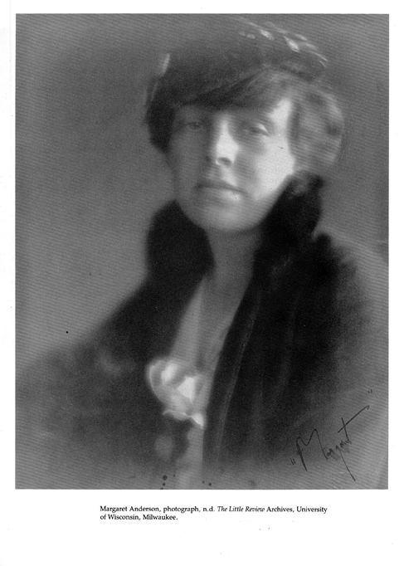

**Fig. 1** (N.D.) Margaret Anderson, photograph, *The Little Review* Archives, University of Wisconsin, Milwaukee. Reproduced as fig.8.3 in Platt, S. N. (1990) ‘*The Little Review*: Early Years and Avant-Garde Ideas’ in *The Old Guard and the Avant-Garde: Modernism in Chicago, 1910-1940*, ed. S. A. Prince, Chicago: University of Chicago Press, following p 144. Reproduction and Permissions information can be found at <<http://bit.ly/NSDClM>>.